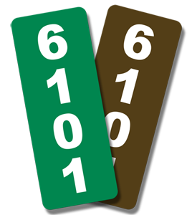

The Almira Fire & EMS Department sells reflective 911 signs to help first responders find addresses more effectively in an emergency. They are a great housewarming gift, or just purchase one for yourself!

PLEASE CIRCLE YOUR CHOICES BELOW
ONE-SIDED ($18.00) or TWO-SIDED ($20.00)
BLUE, RED, GREEN, OR BROWN
VERTICAL or HORIZONTAL

Name: _________________________
Address Number on Sign: ________________
Contact Number: ____________________
Do you need help with installation? Yes No

